**Relation Algebra Exercise**

Recall that the database schema consists of four relations, whose schemas

are:

* Product(maker, model, type)
* PC(model, speed, ram, hd, price)
* Laptop(model, speed, ram, hd, screen, price)
* Printer(model, color, type, price)

Sample data is in .csv files.

1. Write expressions of relational algebra to answer the following queries and

show the result of your query.

a) What PC models have a speed of at least 3.00?

R1: = σspeed ≥ 3.00(PC)

R2: = πmodel(R1)

|  |
| --- |
| model |
| 1005 |
| 1006 |
| 1013 |

b) Which manufacturers make laptops with a hard disk of at least 100GB?

R1: = σhd ≥ 100(Laptop)

R2: = Product Picture 1 (R1)

R3: = πmaker (R2)

|  |
| --- |
| maker |
| E |
| A |
| B |
| F |
| G |

c) Find the model number and price of all products (of any type) made by

manufacturer B.

d) Find the model numbers of all color laser printers.

e) Find those manufacturers that sell Laptops, but not PC ’s.

! f) Find those hard-disk sizes that occur in two or more PC’s.

! g) Find those pairs of PC models that have both the same speed and RAM.

A pair should be listed only once; e.g., list (i, j) but not (j, i).

!! h) Find those manufacturers of at least two different computers (PC’s or

laptops) with speeds of at least 2.80.

!! i) Find the manufacturer(s) of the computer (PC or laptop) with the highest

available speed.

!! j) Find the manufacturers of PC ’s with at least three different speeds.

!! k) Find the manufacturers who sell exactly three different models of PC.

1. Draw expression trees for each of your above expressions

a)

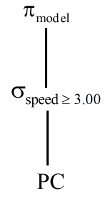

b)

**Relational Algebra Expression Examples**

* Movies(title, year, length, genre, studioName, producerC#)
* MovieStar(name, address, gender, birthdate)
* StarsIn(movieTitle, movieYear, starName)
* MovieExec(name, address, cert#, netWorth)
* Studio(name, address, presC#)

Query: What are the titles and years of movies made by Fox that are at least 100

minutes long?

Solution:

1. Select those Movies tuples that have length > 100.

2. Select those Movies tuples that have studioName = ’Fox’.

3. Compute the intersection of (1) and (2).  
4. Project the relation from (3) onto attributes title and year.

* RA Expression:

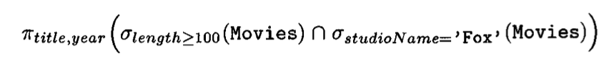

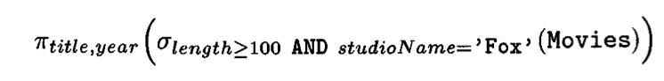

* RA Expression tree

* Linear Notion:

